MS SQL SERVER
Standard Operating Procedures
(SOP)

Submitted to



By



CIS, Wipro Technologies

Document Details

Project Name | Innogy SE
Account | CIS
IT Component/Application Title | Database Password Policy
Current Version | 1.5
List of Contributors | Pradipkumar Kansara, Kiran Bhalekar, Ayushi Gautam, Sivakumar Goud, Nanda Kishore Reddy
Customer Contact Information

Version History
(All revisions made to this document must be listed in chronological order. All revisions must be approved. Review and Approval can be done by an internal source or by the customer)
Version | Date of Revision | Description | Author | Reviewed By | Approved By
1.0 | 29-08-2015 | Initial Draft | Kiran Bhalekar | Pradipkumar Kansara | Mahesh Keshatwar
1.1 | 04-09-2015 | Document Completed | Kiran Bhalekar | Pradipkumar Kansara | Mahesh Keshatwar
1.2 | 21-08-2016 | Updated document to standard format | Kiran Bhalekar | Pradipkumar Kansara | Mahesh Keshatwar
1.3 | 17-05-2017 | Wipro and Innogy Logo changed | Kiran Bhalekar | Pradipkumar Kansara | Mahesh Keshatwar
1.4 | 29-08-2017 | Updated document to Wipro Standard format with header and footer | Sivakumar Goud | Pradipkumar Kansara | Santosh Badiger
1.5 | 15-09-2018 | Updated the content | Nanda Kishore Reddy | Pradipkumar Kansara | Santosh Badiger

Table of contents

Introduction 3
Overview 3
Scope 3
Audience 3
Glossary 3
Detailed Procedure 4
Sample Code : 5
Credentials 5
Sample Code: 6
FAQ 6

Introduction

Overview
This document has the information and standards with regards to passwords used by SQL logins. The aim is to enforce and understand the significance of having this policy and this has to be enforced during any time of the project. It also describes best practices and standards should be applied for any projects.

Scope

This document is only for SQL server DBMS users who are supporting various. The scope of this document is limited to the SQL Server DBMS. Adequate future policies or best standard will be updated in this same document and published in Knet site.

Audience
This document is intended to use by Wipro Database Tower team, Architects and other users who is working on sql server intensively.

Glossary
The following terms and acronyms are used in this document:
Term | Definition
SA | SQL Server’s “System Administrator” account. A SQL Server login that has unrestricted (sysadmin) access to a SQL Server instance.

Detailed Procedure

SQL Server Login passwords under SQL server 2005 and later

There are three main things to be considered when we use SQL Authentication.
- Enforce Password Policy
- Enforce Password Expiration
- User must change password at next login

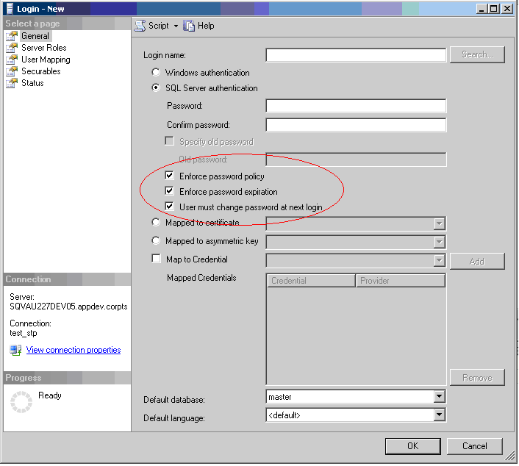

- Whenever SQL Server logins are used (SQL authentication) in SQL Server 2005, the Enforce Password Policies option will be set on to ensure that strong passwords are enforced, passwords are not reused, and accounts are locked out after 3 failed login attempts. Turning this option off must avoided
- If any interactive logins (password will be entered by human) will be used under sql server 2005 or later, then Enforce Password Policies should be on and force the users to change the password very regularly. Note that this is only applies if the SQL Server communication technology used by the application actually supports this feature (i.e. the SQL Server Native Client). This does not apply to SQL Logins that are used by application services (such as WAS or other applications that run as a windows service) as non-interactive processes cannot change the passwords.
- The “sa” account will have the Enforce Password Expiration set on in all SQL Server 2005 (and later) systems. All SA accounts are expected to have their passwords changed weekly by some automated tool or scripts.
- Enforce all sql login passwords should be complex or there has to be a tool which generate passwords every week or required basis. It has to be complex enough.

Sample Code :

CREATE LOGIN Test WITH PASSWORD = hy!at54Cq MUST_CHANGE,
DEFAULT_DATABASE = New,
CHECK_EXPIRATION = ON,
CHECK_POLICY = ON
go

Sample code To Unlock :

ALTER LOGIN Test WITH PASSWORD = 'hy!at54Cq' UNLOCK

In same cases, DBA may want to turn off the password expiration enforcement or security policy enforcement, which can be done with ALTER LOGIN:

ALTER LOGIN Test WITH CHECK_EXPIRATION = OFF
go

ALTER LOGIN Test WITH CHECK_POLICY = OFF
go

Credentials
SQL server 2005 introduces to access resources outside sql server using .Net procedural code. This is another way of controlling security levels on assemblies. When accessing resources outside the database, sql server logins have no specific privileges, It can understand only windows principals define to sql server.
So far, we have only two choices for using external resources and sql logins.
- Use the service account (Service that run sql server)
- Use the guest Account (which is always disabled on OS)

In SQL server 2005, We can assign windows credentials to SQL server logins by first cataloging then with SQL server. The same credentials can be assigned to multiple SQL server logins.

Sample Code:
CREATE CREDENTIAL IBNewsqlusers
WITH IDENTITY = 'InternetBankingUsers', SECRET = '*3DsecUre)'
go
CREATE LOGIN IBUser WITH PASSWORD = 'IBUser'
GO

ALTER LOGIN IBUser WITH CREDENTIAL = sqlusers
GO
Note that the Windows principal (InternetBankingUsers, in this case) must already be defined to the Windows security system.

FAQ

1) On what versions of SQL Server is the password policy available?

Answer: It is available from SQL server 2005 & Later

2) How do I access this feature from SQL server Management Studio?

Answer: A GUI can be used to manage this feature. This can be achieved through T-SQL as well.

Server Name → Logins

TSQL scripts are provided above.

3) How do I check the password policy settings on my system?

Answer: Execute secpol.msc, then look at Account Policies. If you are on a standalone machine and you are an administrator, you can change these settings. If your machine is joined to a domain, these settings are controlled by the domain administrator.

4) I am running SQL Server on Windows XP/2000, etc. Does this mean I cannot benefit from password policy enforcement?

Answer: Yes. On OSs that don't support the password policy API, SQL Server only performs a tiny number of checks on the password strength - to prevent you, for example, from using an empty password. These checks are governed by the CHECK_POLICY settings, so they can be turned off or on. If you ever hit a password policy error on older OSs than Windows 2003, then you really need to revisit the method you are using to pick passwords.

5) I keep getting messages about my password not being acceptable when creating a new login. How do I fix this?
Answer: The error message will usually indicate what the problem is; for example, it will tell you if the password is too short. To find more details about what restrictions are in place for passwords, you can check the policy settings using the secpol.msc tool, as described in a previous answer. You can also disable the policy enforcement for the login, but this is not recommended as it can make that login more vulnerable to a bruce force attack.

